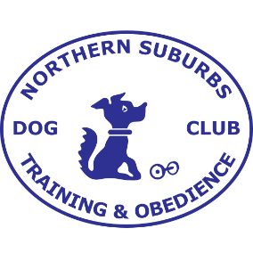
APPLICATION FOR MEDALLION (CLUB TITLE)

Please complete a separate form for each title if applying for more than one.
Passes achieved in open trials can be used towards a club title and included as part of this submission.
The number of passes required for each title are detailed below:
CPD 3
OBD 3
OID 3
OAD 3
OADX 3
Club Rally Novice 3
Club Rally Advanced 3
Club Rally Excellent 5
Club Rally Masters 7
Forward your completed form/s with a copy of your qualification cards to: competitions@northernsuburbsdogclub.org by 30th November.
NAME OF DOG
BREED
OWNER
TITLE

 | Club conducting event (NSTODC/Dogswest) | Date | Judge | Points
1st pass
2nd pass
3rd pass
4th pass
5th pass
6th pass
7th pass

